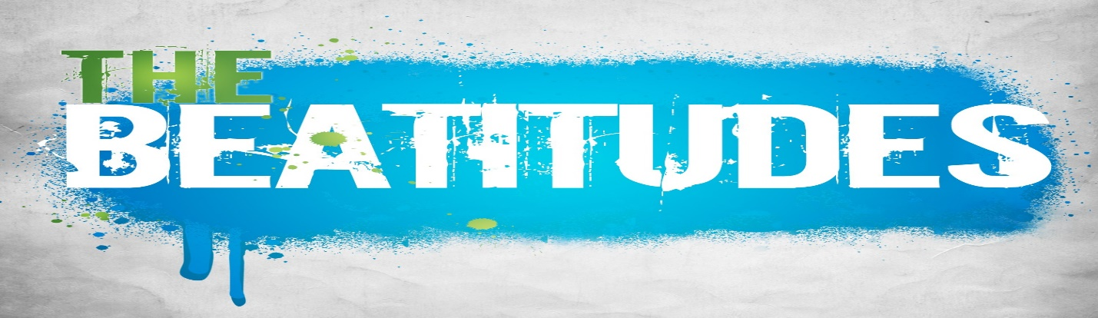

Be-Attitudes (Attitude Changer)
Part 7 - “Be A Peacemaker” by Pastor Harv Lyon
June 11, 2023

Their heart is not right with God

“If anyone is in Christ they are a new creation.” – 2 Corinthians 5:17

Matthew 7:24-27

“Blessed are the peacemakers, for they shall be called sons of God.” – Matthew 5:9

“God’s highest good to you.”

1. Peacemakers seek to reconcile people ________________. - Romans 5:1

“Peace without righteousness is just a truce with sin.” - 2 Corinthians 5:18-21

2. Peacemakers seek to reconcile ________________. - Romans 12:18 Philippians 4:2-3

Satan is the ____________, but Christ is the _________________. - Ephesians 4:26-27, 29

How wonderful and pleasant it is when brothers live together in harmony! For harmony is as precious as the anointing oil that was poured over Aaron’s head, that ran down his beard and onto the border of his robe. Harmony is as refreshing as the dew from Mount Hermon that falls on the mountains of Zion. And there the Lord has pronounced his blessing, even life everlasting. – Psalm 133

How can I be a reconciler?

(A) Reconcilers are ________________. - James 1:19-20

(B) Reconcilers focus on __________________. - Ephesians 4:3-6
(C) Reconcilers seek the _____________________. - Ephesians 5:18 Galatians 5:18, 22-23
(D) Reconcilers rely on ______________________. - Hebrews 4:12-13
Do I seek to reconcile people to God? (Do I share my testimony?)
Do I seek to reconcile people?
Peacemakers focus on:
- Listening
- Commonality
- Holy Spirt
- God’s Word

CrossPointe Staff |  | Phone | Email
Senior Pastor | Harv Lyon | 813-355-1383 | harvlyon@gmail.com
Children’s Director | Edythe Lyon | 813-355-1387 | edythe@crosspointetampa.com
Youth Director | Dan Chauncy | 813-712-0808 | danielchauncy@yahoo.com
Executive Director | Craig Vance | 813-376-5921 | craigvance0511@gmail.com

Upcoming Special Events at CrossPointe:
Find us on Social Media: YouTube: @CrossPointeFamilyChurch Instagram: Church - @crosspointetampa Youth - @Refuge429
Facebook:
Church - www.facebook.com/cpctampa
Youth - www.facebook.com/refuge777
June 11th – Family Fun Day (Brown Bag Lunch)
June 19th-23rd – Lake Placid Camp (7-12th grade)
July 3rd-9th – Nazarene Youth Conference (High School)
July 31st-August 4th – Lake Placid Kids Camp

Weekly Places to Plug In:
Adult Bible Studies, Young Adult Bible Studies, Youth Group, Kid’s Group, Creator Space, Prayer Groups, PALS 55+ Group, Amazing Grace Ministries, Mission Trips, Softball Team, Media Team, Greeting Team, Grounds Team & more!
Answers:
1. To God

2. People

Satan is the divider, but Christ is the reconciler.

(A) Listeners

(B) Commonality

(C) Holy Spirit

(D) God’s Word

For more details go to
CrossPointeTampa.com
or call the office at 813-949-7727.

